**Social Media Scheduling Mobile Application**

|  |  |  |  |
| --- | --- | --- | --- |
| Md Hasib Zaman  Department of Electrical and Computer Engineering  North South University Dhaka, Bangladesh  hasib.zaman@northsouth.edu | Jahin Mahbub  Department of Electrical and Computer Engineering North South University Dhaka, Bangladesh jahin.mahbub@northsouth.edu | Yeahia Mahammad Arif  Department of Electrical and Computer Engineering North South University Dhaka, Bangladesh yeahia.arif@northsouth.edu | Shaikh Shawon Arefin Shimon  Lecturer  Department of Electrical and Computer Engineering  North South University  Dhaka, Bangladesh  shaikh.shimon@northsouth.edu |

**Abstract**

Social Media involvement in our life has been increasing day by day and maintaining this social media life has become more difficult. Sometimes we might have to post our contents remotely even when we are away from our workspace or we might have to post something on a specific time but we might be busy on that time. So, these issues bring to our solution, the social media scheduler application where people can schedule their social media posts and they can post from multiple platforms from one hub.

**Keywords**

Social Media; influencer; online business; Schedule Post;

# Introduction

People are controlling their personal and business life both in social media. They have to come up with ideas day by day to upload their content. But often they forget the content which they thought of. In the past people used to follow the classical way and write in a notebook. After a while they thought of jolting it down on a notepad, a software for keeping notes. But in recent times life has been made easier. Social Media applications have added the feature of scheduling posts. But nowadays we also have to maintain not only social media accounts but many more concerned sites to keep our business running smooth and contents to reach out people effectively.

The Social Media scheduler is an application that appoints or schedules post/tweets for social medias. The application will be a mobile application. It will be running on both IOS and Android.

The purpose of the project is to make people's day to day life easier, give them the opportunity to use social media remotely and easy maintenance of their social media accounts from one hub and post when they are roaming.

We have a huge target audience, everyone who is on social media can be our target. Our special targets would be those who use their social media to conduct business.

# Background

Nowadays there are a huge number of social media sites . That’s why target platforms are scattered but after a thorough research, we came up with a few social media sites that we can support through our application if their privacy allows us: Facebook, Twitter, Instagram, Linkedin, Tiktok, Reddit, Snapchat, Quora.

Every social site has their own way and their posting methods are different. Some of them can add images and in some if image is mandatory.

|  |  |  |  |  |  |  |
| --- | --- | --- | --- | --- | --- | --- |
| Social Media | Post | Image | Video | Caption | Character Limit | Stories |
| Facebook | ✔ | ✔ | ✔ | ✔ | 63,206 | ✔ |
| Twitter | ✔ | ✔ | ✔ | ✔ | 280 | ✖ |
| Instagram | ✔ | ✔ | ✔ | ✔ | 2200 | ✔ |
| Linkedin | ✔ | ✔ | ✔ | ✔ | 1300 | ✔ |
| Tiktok | ✔ | ✖ | ✔ | ✔ | 100 | ✔ |
| Reddit | ✔ | ✔ | ✔ | ✔ | 40,000 | ✖ |
| Snapchat | ✖ | ✔ | ✔ | ✖ | ✖ | ✔ |
| Quora | ✔ | ✔ | ✔ | ✔ | 40,000 | ✖ |

The potential market competitors against our project that we have noticed of are: SocialPilot, HootSuite, Buffer, Sendible, AgoraPulse, Sprout Social, CoSchedule, Zoho Social, eClicher, MavSocial, MeetEger, SmartQueue, Facebook Business suite, Combin Free Instragram Scheduler.

**Facebook Business suite-**

Facebook business suite is the official application tool that helps to organize your facebook page and Instagram page. It has a web version and an ios and android version as well. The feature that it holds are:

* View your business at a glance
* View Activity
* Use Inbox
* Create Posts and Stories
* Access Commerce Manager
* Create Ads
* View Insights
* Access More Tools
* Schedule posts

The business suite has a very nice way of scheduling post. It would be considered the best in our opinion. It uploads the whole file in a server and posts when it's scheduled. It also shows the preview of the scheduled post.

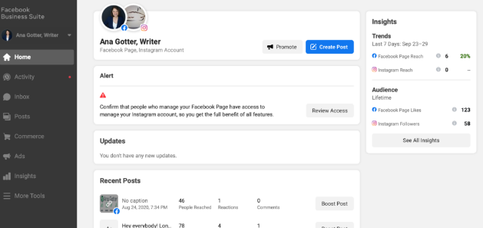

Figure 2.1: Facebook business suite

**Combin Free Instragram Scheduler-**

Combin's goal is to provide efficient Instagram marketing solutions. It doesn't have any mobile version. It only offers a desktop version. The application has to be running in the background to post on Instagram. It doesn't support any other platform and medias.

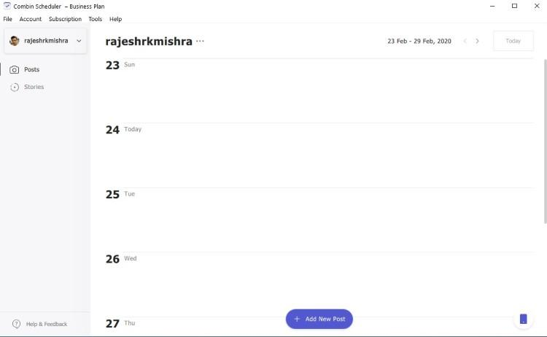

Figure 2.2: Combin-Scheduler

**Buffer-**

Buffer is another social media management tool. It allows you to manage multiple accounts with pricing. Buffer offers using facebook, twitter, Instagram and Linkedin to connect and schedule post. It uploads everything required to some cloud storage and then posts when it's required to. Buffer has an analytic section as well which gives the user some insights about the posts.

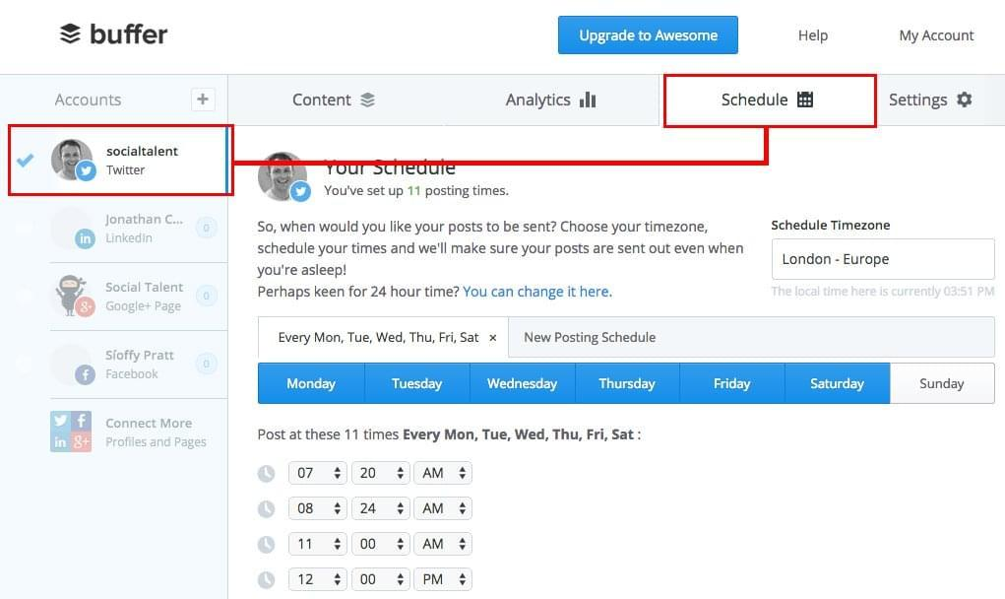

Figure 2.3: Buffer Social Media

**Hootsuite-**

Hootsuite is another useful application for managing social media network channels. Often referred to as a social media management system or tool, it enables you to view multiple streams at once and monitor what customers are saying. You can post updates, read responses, schedule messages, view statistics, and much more. Many international brands—including Coca-Cola and Sony Music—utilize this timesaving approach to social media marketing. With Hootsuite, you can post updates, review responses, and connect with your customer base on over thirty-five popular social networks, including Twitter, Facebook (includes Profiles, Events, Groups, and Fan Pages), LinkedIn (includes Profiles, Pages, and Groups), Google+, Foursquare, WordPress blogs and several other platforms via third party apps.

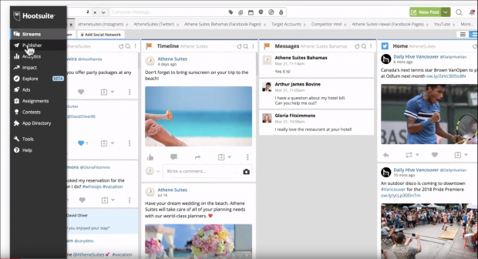

Figure 2.4: Hootsuite

**SocialPilot-**

SocialPilot is a social media scheduling and marketing platform developed specifically for agencies and social media professionals. Used by over 40,000 agencies and social media teams, SocialPilot is designed to help users enhance the efficiency of their online marketing strategies and efforts, and save time and money. Moderately priced and appropriately integrated, SocialPilot is meant to be accessible for businesses of all scales and industries. In fact, there is a free starter package for 3 connected profiles you could use to examine the features, and confirm SocialPilot is a smart choice for your business.

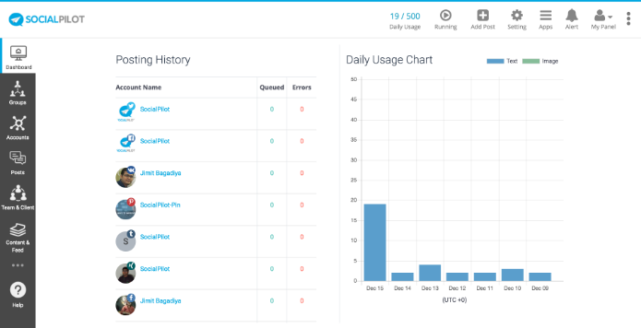

Figure 2.5: SocialPilot

**Sendible-**

The Sendible platform brings all your social networks together into a centralized hub and is the easiest way to execute a winning social media strategy for multiple brands at scale. Positioned as a productivity tool for agencies, you can be certain that your team will save hours of time!

With powerful social media engagement, monitoring, publishing, lead generation and reporting features, Sendible gives you all the tools to delight your clients every step of the way.

Sendible's social media automation features help to simplify the process of driving interactions, growing a following and starting conversations on social media. The unified Priority Inbox is loved by brands and agencies alike, who are saving hours each day by consolidating the most important conversations from multiple sources into a single stream. With gorgeous social media reports that are designed to impress, you can deliver both meaningful and impressive-looking insights showcasing your progress on social media.

**eClincher-**

eclincher platform is built for companies who are looking for an intuitive yet powerful solution to manage their brand reach, reputation and growth online. Popular features include: suggested content & free media assets, live inbox to interact across all channels / message types, post editing, scheduler & visual calendar, post boost, monitoring with live feeds, smart queues & auto posting, analytics & reports, team collaboration & workflows, mobile app.

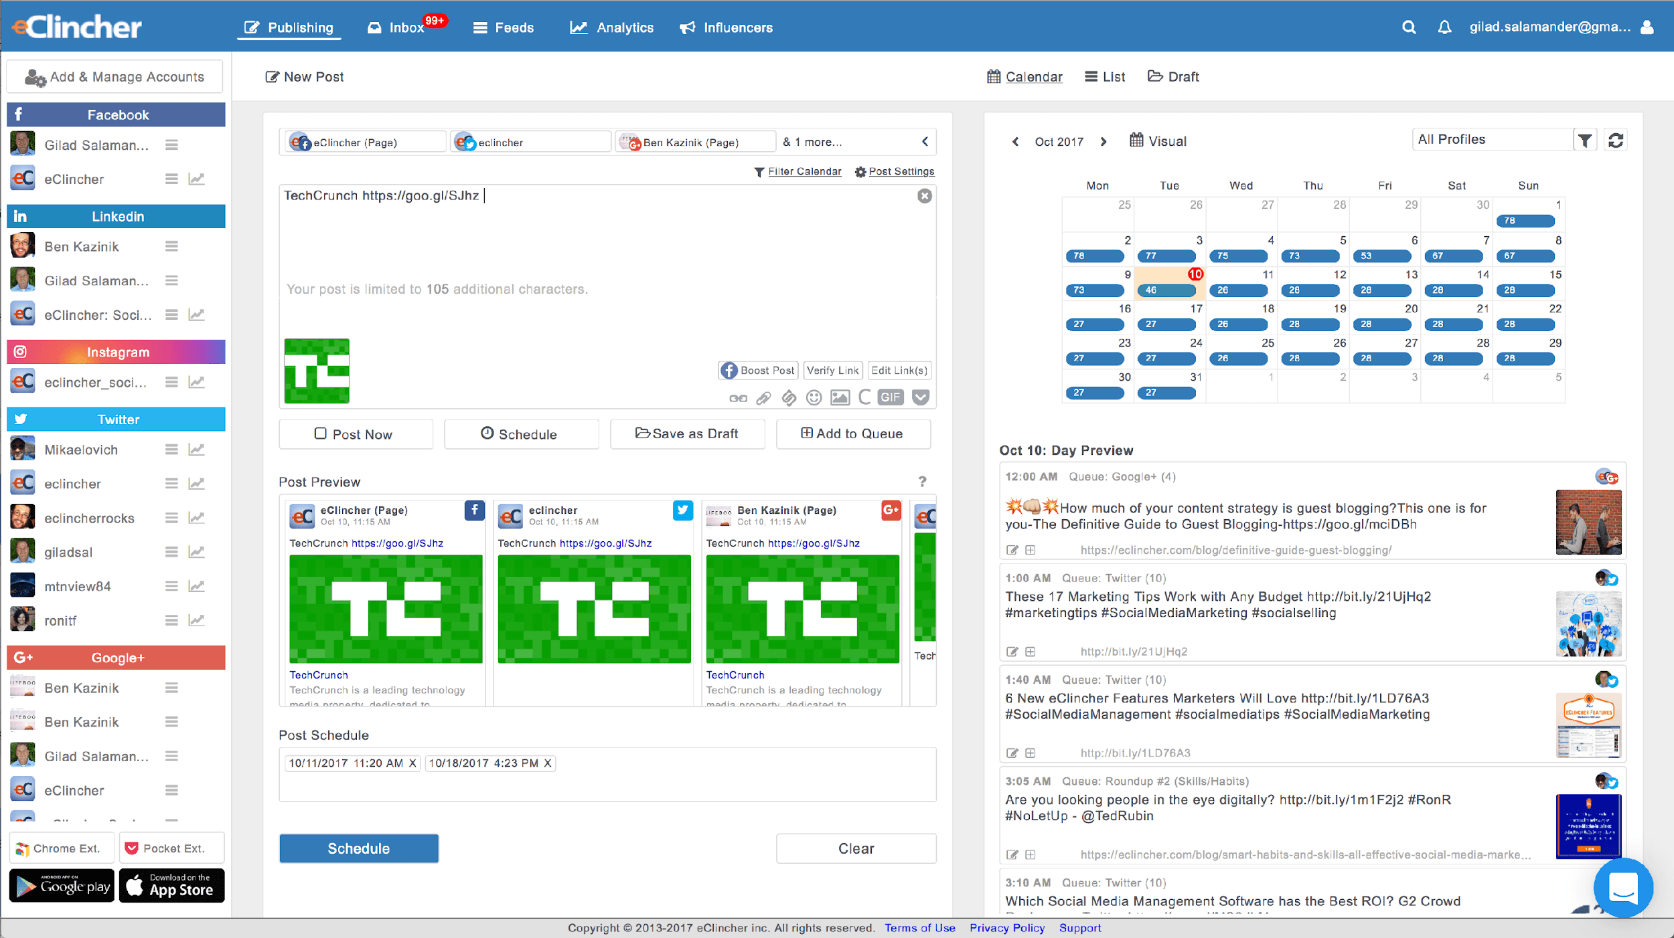

Figure 2.6: eClincher

**Sprout Social**

Sprout Social offers powerful social customer service solutions for leading agencies and brands including Hyatt, Ogilvy, Leo Burnett, Evernote and Microsoft. Sprout enables brands to simplify social monitoring, listening, customer service, engagement and much more. Sprout supports Facebook, Twitter, Instagram, LinkedIn and Google+ & integrates with Bitly, Google Analytics, Zendesk, Feedly & UserVoice.

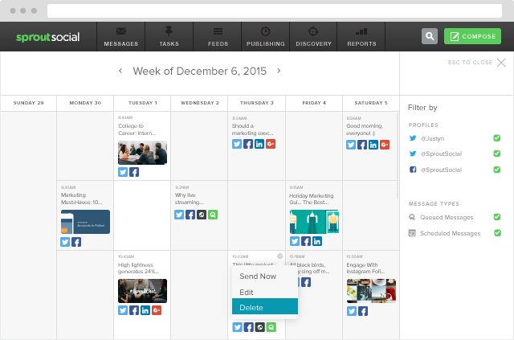

Figure 2.7: Sprout Social

|  |  |  |  |  |  |  |  |  |
| --- | --- | --- | --- | --- | --- | --- | --- | --- |
| Application | Scheduling | Analytics | Moderation | Collaboration | Content Curation | Bulk Scheduling | Cost of 5 user | Free Version |
| SociaPilot | ✔ | ✔ | ✔ | ✔ | ✔ | ✔ | 50/m | ✖ |
| Hootsuite | ✔ | ✔ | ✔ | ✔ | ✔ | ✖ | 599/m | ✔ |
| Buffer | ✔ | ✔ | ✖ | ✔ | ✖ | ✖ | 99/m | ✔ |
| Sendible | ✔ | ✔ | ✔ | ✔ | ✔ | ✔ | 199/m | ✖ |
| AgoraPulse | ✔ | ✔ | ✔ | ✔ | ✖ | ✖ | 199/m | ✖ |
| Sprout Social | ✔ | ✔ | ✔ | ✔ | ✔ | ✔ | 149/m | ✖ |
| CoSchedule | ✔ | ✔ | ✖ | ✔ | ✖ | ✖ | 400/m | ✖ |
| Zoho Social | ✔ | ✔ | ✔ | ✔ | ✖ | ✔ | 200/m | ✖ |
| eClicher | ✔ | ✔ | ✔ | ✔ | ✔ | ✔ | 219/m | ✖ |
| MavSocial | ✔ | ✔ | ✔ | ✔ | ✔ | ✔ | 199/m | ✖ |
| MeetEger | ✔ | ✔ | ✖ | ✖ | ✖ | ✔ | 49/m | ✖ |
| SmartQueue | ✔ | ✔ | ✖ | ✖ | ✔ | ✔ | 79.99/m | ✖ |

.

# Purpose

The purpose of our project is to provide a solution to our target audience and the we plan to launch an android application.

# Proposal

Architecture Pattern- Architectural pattern of the proposed application is given below.

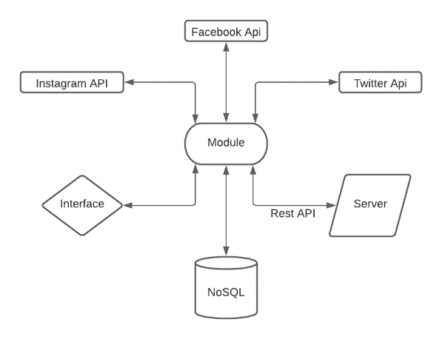

Figure 4.1: Architecture Pattern

We will be using MVVM architecture for our Application.

MVVM - MVVM architecture is a Model-View-ViewModel architecture that removes the tight coupling between each component. Most importantly, in this architecture, the children don't have the direct reference to the parent, they only have the reference by observables.

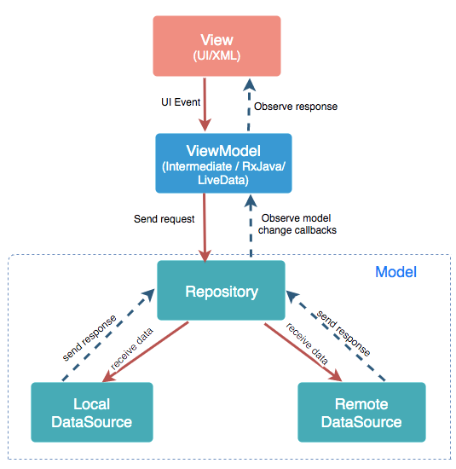

Figure 4.2: MVVM Architecture

.

Model: It represents the data and the business logic of the Android Application. It consists of the business logic - local and remote data source, model classes, repository.

View: It consists of the UI Code(Activity, Fragment), XML. It sends the user action to the ViewModel but does not get the response back directly. To get the response, it has to subscribe to the observables which ViewModel exposes to it.

ViewModel: It is a bridge between the View and Model(business logic). It does not have any clue which View has to use it as it does not have a direct reference to the View. So basically, the ViewModel should not be aware of the view who is interacting with. It interacts with the Model and exposes the observable that can be observed by the View

For our Database we will be using NOSQL database. Firebase is used in Backend-as-a-Service. It provides developers with a variety of tools and services to help them develop quality apps, grow their user base, and earn profit. It is built on Google’s infrastructure.

Authentication: It supports authentication using passwords, phone numbers, Google, Facebook, Twitter, and more. The Firebase Authentication (SDK) can be used to manually integrate one or more sign-in methods into an app.

Realtime database: Data is synced across all clients in real-time and remains available even when an app goes offline.

Hosting: Firebase Hosting provides fast hosting for a web app; content is cached into content delivery networks worldwide.

Test lab: The application is tested on virtual and physical devices located in Google’s data centers.

Notifications: Notifications can be sent with firebase with no additional coding.

We have also made a user interface design with figma to explain our idea more properly.

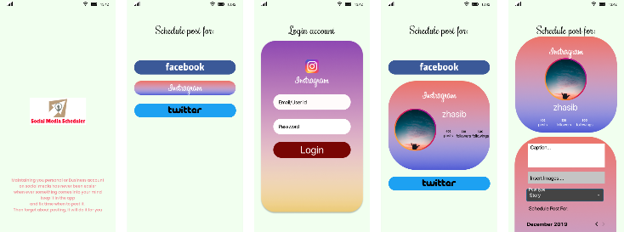

Figure 4.3: User Interface Prototype

# Findings

TBA

# Conclusion

Initially, our plan is to execute the social media application for Instagram, Facebook and Twitter. Afterwards we plan to extend our platform.

# Acknowledgement

We would like to thank and gratitude to their supervisor Shaikh Shawon Arefin Shimon for continuous guidance and encouragement throughout the project. We take this opportunity to express gratitude to all of the Department of electrical and computer science of North South University and all faculty members for their help and support. We also thank our parents for their love and support. Finally, we would also like to appreciate to the efforts of the authors whose papers and article helped us a lot throughout our research.

# References

1. Bowman, M., Debray, S. K., and Peterson, L. L. 1993. Reasoning about naming systems. *ACM Trans. Program. Lang. Syst.* 15, 5 (Nov. 1993), 795-825. DOI= <http://doi.acm.org/10.1145/161468.16147>.
2. Ding, W. and Marchionini, G. 1997. *A Study on Video Browsing Strategies*. Technical Report. University of Maryland at College Park.
3. Fröhlich, B. and Plate, J. 2000. The cubic mouse: a new device for three-dimensional input. In *Proceedings of the SIGCHI Conference on Human Factors in Computing Systems* (The Hague, The Netherlands, April 01 - 06, 2000). CHI '00. ACM, New York, NY, 526-531. DOI= <http://doi.acm.org/10.1145/332040.332491>.
4. Tavel, P. 2007. *Modeling and Simulation Design*. AK Peters Ltd., Natick, MA.
5. Sannella, M. J. 1994. *Constraint Satisfaction and Debugging for Interactive User Interfaces*. Doctoral Thesis. UMI Order Number: UMI Order No. GAX95-09398., University of Washington.
6. Forman, G. 2003. An extensive empirical study of feature selection metrics for text classification. *J. Mach. Learn. Res.* 3 (Mar. 2003), 1289-1305.
7. Brown, L. D., Hua, H., and Gao, C. 2003. A widget framework for augmented interaction in SCAPE. In *Proceedings of the 16th Annual ACM Symposium on User Interface Software and Technology* (Vancouver, Canada, November 02 - 05, 2003). UIST '03. ACM, New York, NY, 1-10. DOI= <http://doi.acm.org/10.1145/964696.964697>.
8. Yu, Y. T. and Lau, M. F. 2006. A comparison of MC/DC, MUMCUT and several other coverage criteria for logical decisions. *J. Syst. Softw.* 79, 5 (May. 2006), 577-590. DOI= <http://dx.doi.org/10.1016/j.jss.2005.05.030>.
9. Spector, A. Z. 1989. Achieving application requirements. In *Distributed Systems*, S. Mullender, Ed. ACM Press Frontier Series. ACM, New York, NY, 19-33. DOI= <http://doi.acm.org/10.1145/90417.90738>.